DAY-1:
1.Caesor cipher encryption and decryption:
# Caesar Cipher (Short Version)
text = input("Enter text: ")
key = int(input("Enter key (0-25): "))
# Encryption
encrypted = ""
for ch in text:
if ch.isalpha():
encrypted += chr((ord(ch.upper()) - 65 + key) % 26 + 65)
else:
encrypted += ch
print("Encrypted Text:", encrypted)
# Decryption
decrypted = ""
for ch in encrypted:
if ch.isalpha():
decrypted += chr((ord(ch) - 65 - key) % 26 + 65)
else:
decrypted += ch
print("Decrypted Text:", decrypted)
# Brute Force
print("\nBrute Force Results:")
for k in range(1, 26):
temp = ""
for ch in encrypted:
if ch.isalpha():
temp += chr((ord(ch) - 65 - k) % 26 + 65)
else:
temp += ch
print("Key", k, ":", temp)
OUTPUT:
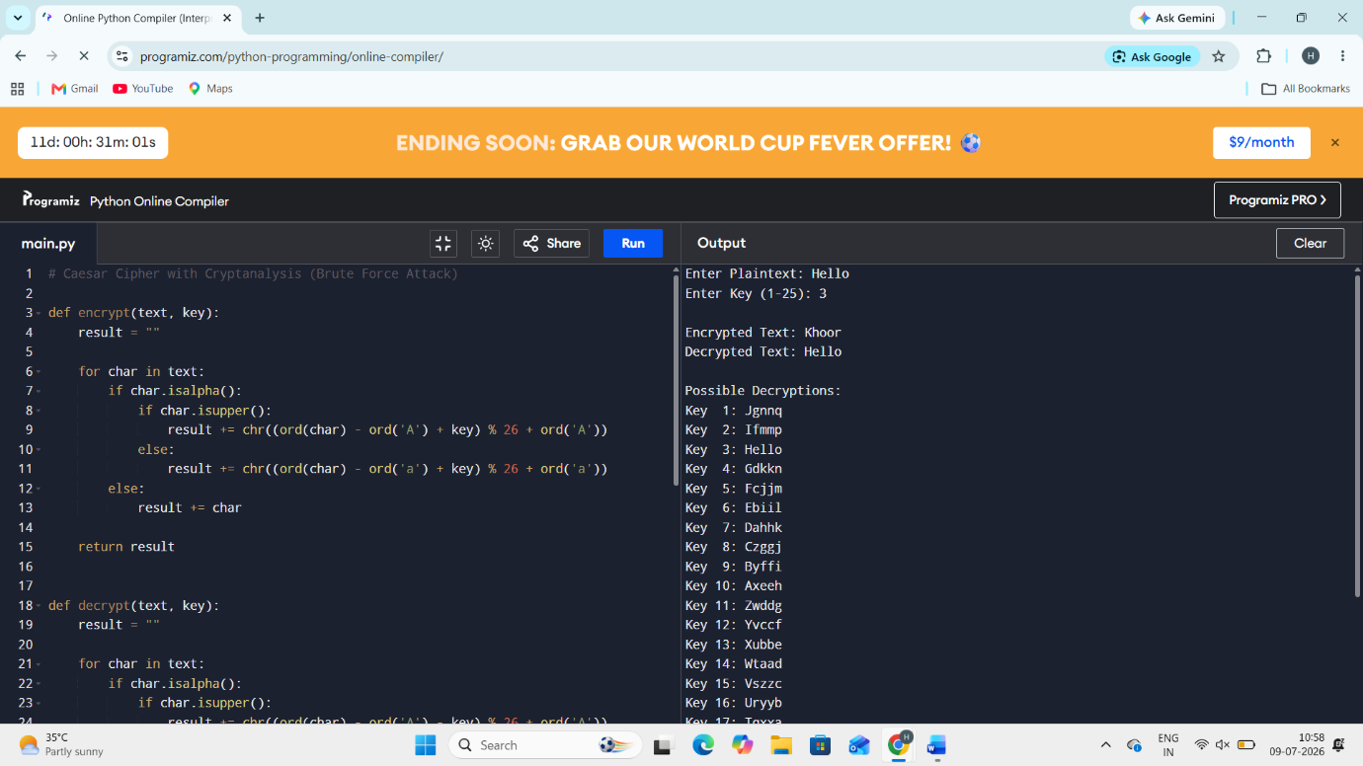
2.MONOALPHABETIC CIPHER WITH FREQUENCY:
import random
import string

# Generate random substitution key
letters = list(string.ascii_uppercase)
shuffled = letters.copy()
random.shuffle(shuffled)
key = dict(zip(letters, shuffled))
print("Substitution Key:")
for k in key:
print(k, "->", key[k], end=" ")
# Input paragraph
text = input("\n\nEnter paragraph: ").upper()
# Encryption
cipher = ""
for ch in text:
if ch in key:
cipher += key[ch]
else:
cipher += ch
print("\nEncrypted Text:\n", cipher)
# Frequency Analysis
freq = {}
for ch in cipher:
if ch in string.ascii_uppercase:
freq[ch] = freq.get(ch, 0) + 1
# Top 3 frequent letters
top3 = sorted(freq.items(), key=lambda x: x[1], reverse=True)[:3]

print("\nTop 3 Most Frequent Letters:")
for letter, count in top3:
print(letter, ":", count)
OUTPUT:
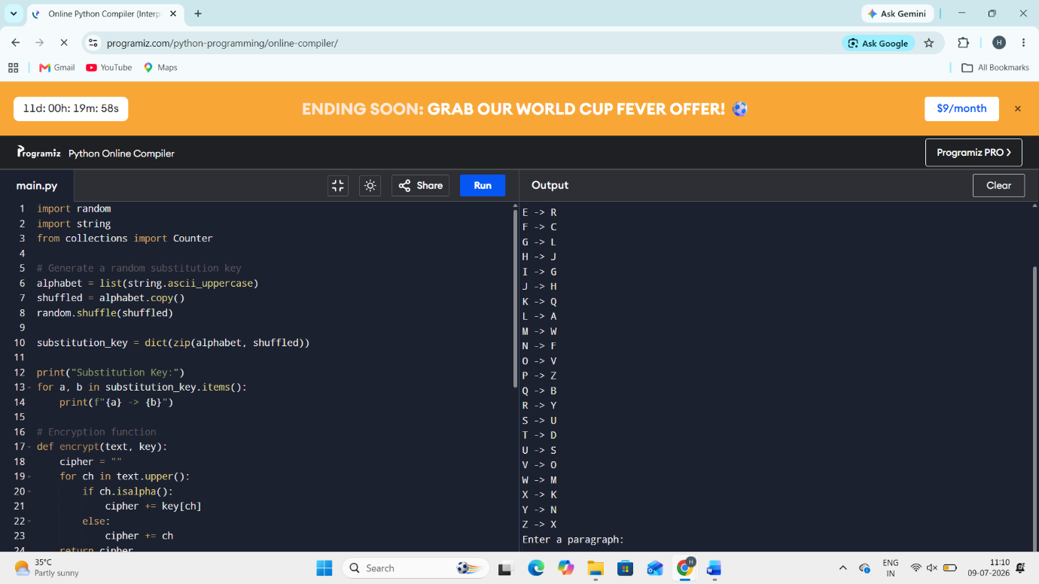
3.VIGENERE CIPHER WITH KEYWORD RECOVERY:
import math
# Function to repeat key
def repeat_key(text, key):
key = key.upper()
return (key * (len(text)//len(key) + 1))[:len(text)]

# Encryption
def encrypt(text, key):
text = text.upper().replace(" ", "")
key = repeat_key(text, key)
cipher = ""
for p, k in zip(text, key):
cipher += chr((ord(p)-65 + ord(k)-65) % 26 + 65)
return cipher

# Decryption
def decrypt(cipher, key):
key = repeat_key(cipher, key)
plain = ""
for c, k in zip(cipher, key):
plain += chr((ord(c)-65 - (ord(k)-65)) % 26 + 65)
return plain

# Basic Kasiski (find repeated 3-letter sequences)
def kasiski(cipher):
seq_pos = {}
for i in range(len(cipher)-2):
seq = cipher[i:i+3]
if seq in seq_pos:
distance = i - seq_pos[seq]
print("Repeated:", seq, " Distance:", distance)
print("Estimated Key Length:", distance)
return
else:
seq_pos[seq] = i
print("No repeated sequence found")
# Main
text = input("Enter plaintext: ")
key = input("Enter keyword: ")
cipher = encrypt(text, key)
print("Ciphertext:", cipher)
plain = decrypt(cipher, key)
print("Decrypted Text:", plain)
print("\nKasiski Analysis:")
kasiski(cipher)
OUTPUT:
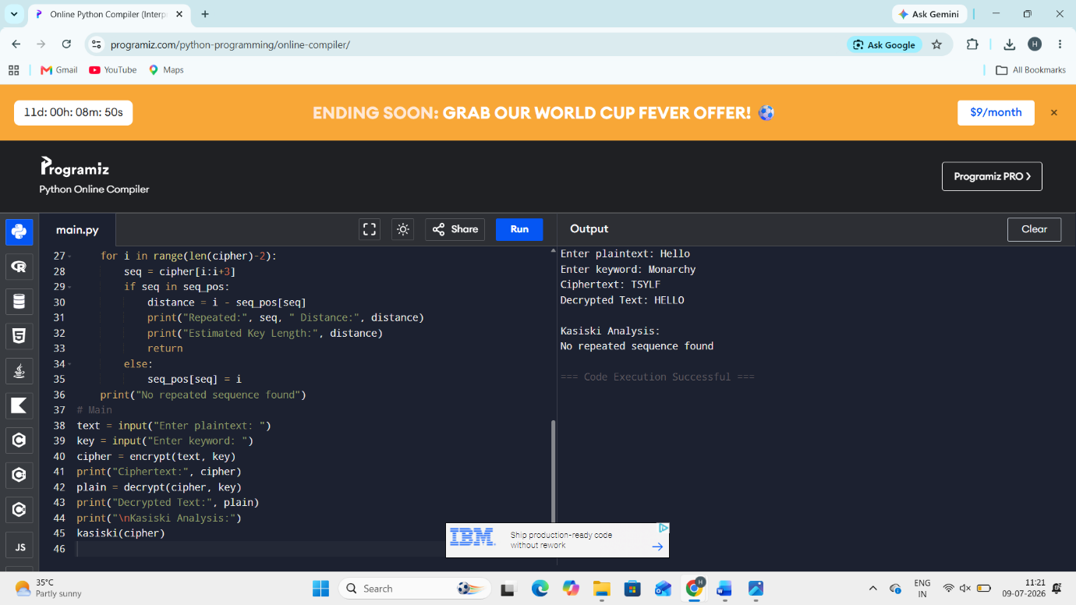
4.HILL CIPHER:
import math

# Function to find modular inverse
def mod_inv(a, m):
for x in range(1, m):
if (a * x) % m == 1:
return x
return None

# Input key matrix
print("Enter 4 values for 2x2 key matrix:")
a = int(input())
b = int(input())
c = int(input())
d = int(input())

det = (a*d - b*c) % 26

# Check validity
if math.gcd(det, 26) != 1:
print("Invalid Key Matrix")
exit()
det_inv = mod_inv(det, 26)
# Inverse matrix
inv = [
[( d * det_inv) % 26, (-b * det_inv) % 26],
[(-c * det_inv) % 26, ( a * det_inv) % 26]
]
# Input plaintext
text = input("Enter plaintext: ").upper().replace(" ", "")
if len(text) % 2 != 0:
text += "X"
# Encryption
cipher = ""
for i in range(0, len(text), 2):
p1 = ord(text[i]) - 65
p2 = ord(text[i+1]) - 65
c1 = (a*p1 + b*p2) % 26
c2 = (c*p1 + d*p2) % 26
cipher += chr(c1 + 65) + chr(c2 + 65)
print("Ciphertext:", cipher)
# Decryption
plain = ""
for i in range(0, len(cipher), 2):
c1 = ord(cipher[i]) - 65
c2 = ord(cipher[i+1]) - 65
p1 = (inv[0][0]*c1 + inv[0][1]*c2) % 26
p2 = (inv[1][0]*c1 + inv[1][1]*c2) % 26
plain += chr(p1 + 65) + chr(p2 + 65)
print("Decrypted Text:", plain)
OUTPUT:
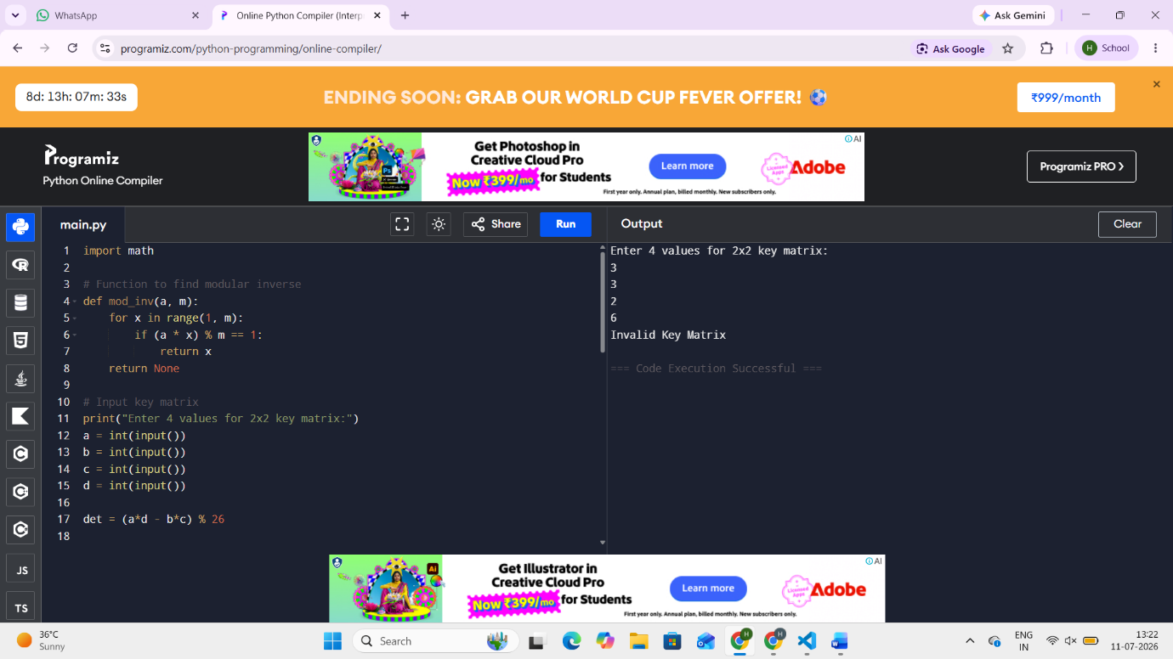
5.SECURITY ANALYSIS OF SUBSTITUTION SIPHER:
import random
import string
import time
import math

# --------- Caesar Cipher ----------
def caesar(text, key):
result = ""
for ch in text:
result += chr((ord(ch)-65 + key) % 26 + 65)
return result

# --------- Monoalphabetic ----------
def mono(text):
letters = list(string.ascii_uppercase)
shuffled = letters.copy()
random.shuffle(shuffled)
key = dict(zip(letters, shuffled))
return "".join(key[ch] for ch in text)

# --------- Vigenere ----------
def vigenere(text, key):
key = (key * (len(text)//len(key)+1))[:len(text)]
result = ""
for p, k in zip(text, key):
result += chr((ord(p)-65 + ord(k)-65) % 26 + 65)
return result

# --------- Hill Cipher (Fixed Key) ----------
def hill(text):
a,b,c,d = 3,3,2,5 # valid key
if len(text)%2 != 0:
text += "X"
result = ""
for i in range(0,len(text),2):
p1 = ord(text[i])-65
p2 = ord(text[i+1])-65
c1 = (a*p1 + b*p2) % 26
c2 = (c*p1 + d*p2) % 26
result += chr(c1+65)+chr(c2+65)
return result

# --------- Frequency Count ----------
def frequency(text):
freq = {}
for ch in text:
freq[ch] = freq.get(ch,0)+1
return freq

# --------- Main ----------
text = input("Enter Plaintext: ").upper().replace(" ","")

# Caesar
start = time.time()
c1 = caesar(text,3)
t1 = time.time()-start

# Mono
start = time.time()
c2 = mono(text)
t2 = time.time()-start

# Vigenere
start = time.time()
c3 = vigenere(text,"KEY")
t3 = time.time()-start

# Hill
start = time.time()
c4 = hill(text)
t4 = time.time()-start

# Display Table
print("\nComparative Analysis")
print("---------------------------------------------------------------")
print("Cipher Ciphertext Time")
print("---------------------------------------------------------------")
print("Caesar ", c1, " ", round(t1,6))
print("Mono ", c2, " ", round(t2,6))
print("Vigenere ", c3, " ", round(t3,6))
print("Hill ", c4, " ", round(t4,6))
print("---------------------------------------------------------------")
OUTPUT:
